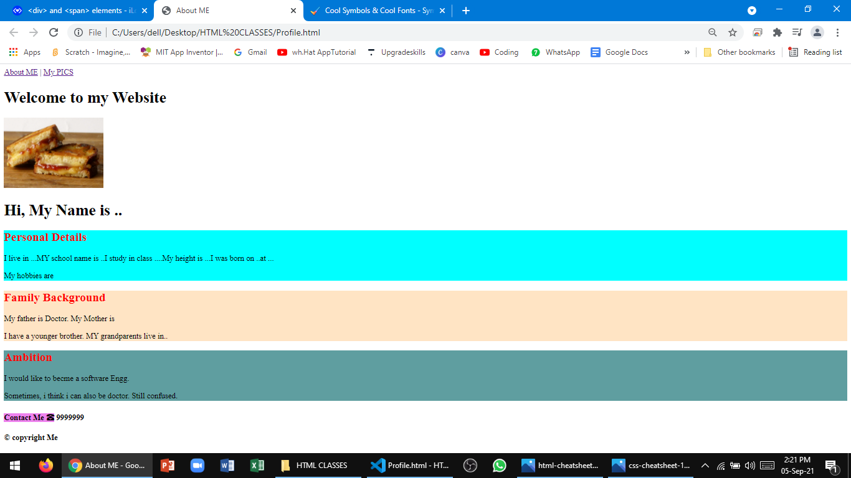

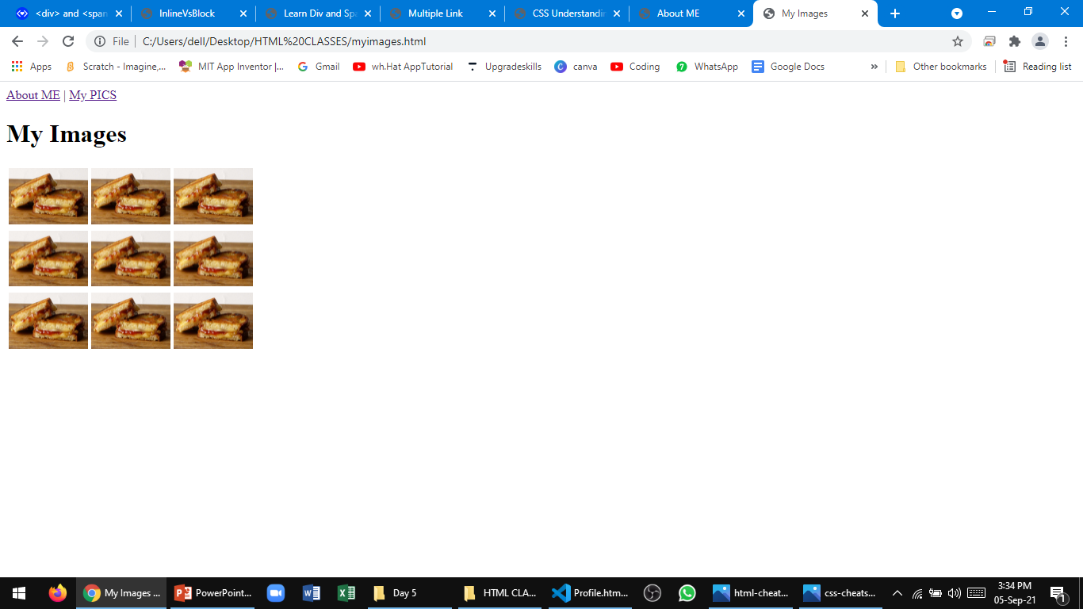

Design a website with 2 pages –

1st page - information about you.

2nd page – Your photos arranged in a Table.